DATE: 24.08.2018
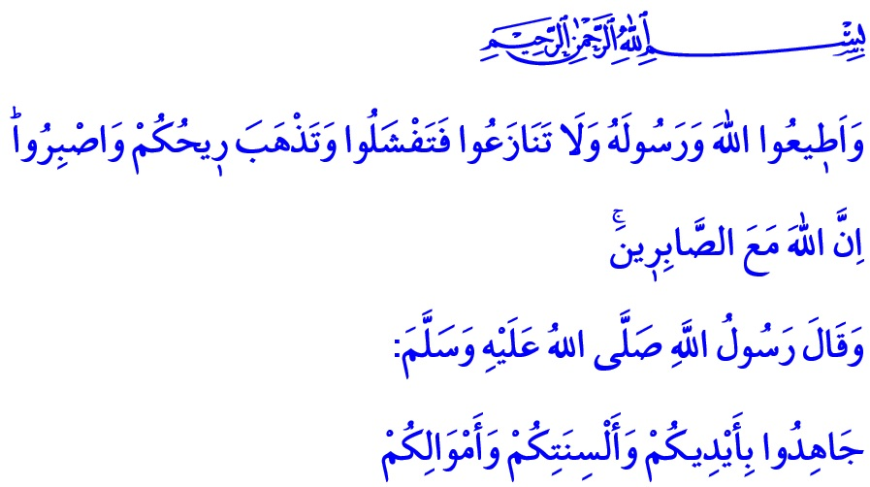 EFFORT IS FROM BELIEVERS, VICTORY IS FROM ALLAH
Honorable Muslims!
Our Almighty Lord (s.w.t.) commands in the verse I have recited, “And obey Allah and His Messenger, and do not dispute and [thus] lose courage and [then] your strength would depart; and be patient. Indeed, Allah is with the patient.”
Our Prophet (s.a.w.) says in the hadith I have read, “Strive in jihad with your hands, your tongues and your wealth.”
Esteemed Muslims!
Homeland is the land on which people live in peace and safety with the honor of being free. It is the country of those who write history with the same courage, who sacrifice their lives for the same values, and who build the future with the same ideals. Homeland is the legacy of those who attained the honor of being a martyr to protect their glory and future, and those who sacrificed their existence and became veterans.
Our ancestors have defended these sacred lands for centuries and struggled heroically against oppression and cruelty with their faith in Allah and love for the homeland. This noble nation, whose only aim is to not let the enemy touch their sacred values, has never let any harm reach their dignity and honor. The victories of Malazgirt, Otlukbeli, Çaldıran, Mercidabık, Mohac, Sakarya and the Great Offensive, which left their marks on history and are commemorated in August annually, bear witness to it.
These auspicious victories have shown that effort is from believers, and victory is from Allah (s.w.t.). The hearts which beat to attain the countenance of Him (s.w.t.) and make goodness prevail the earth can never be enslaved. Those who have designs against the unity and solidarity of our nation, who worships Allah only, are doomed to be disgraced and destroyed. Our flag will continue to wave and our adhan will continue to echo until the lights of the last home on these lands go off.
Honorable Muslims!
Today, we must put on the consciousness of victory in the face of attempts to oppress our country and compel the Islamic geography to surrender. The consciousness of victory means to show patience and perseverance against difficulties. It means to leave the conflicts, disputes and intrigues that consume this nation, resembling a deep-rooted grand plane tree. It means to be alert to those who want to shake our brotherhood and disrupt our affection.
Our noble nation, with their insightfulness and with the aid of Allah, will stop the traitors today as well, just as they made the powerful nations of the world kneel in the past despite the heaviest conditions. Our noble nation will fearlessly resist any kind of economic and technological attack today as well, just as they used their chests as a shield against the July 15 invasion attempt. After all, there is only one truth that does not change even though the name, time, place, and conditions of the battle between right and wrong change, which is the divine decree of:

“O you who have believed, if you support Allah, He will support you and plant firmly your feet.”
Dear Brothers and Sisters!
Let us strengthen our loyalty, submission and trust in Allah (s.w.t.) for the perpetuity of our nation. Let us wholeheartedly believe in the verse of our Almighty Lord (s.w.t.):
“Do not weaken and do not grieve, and you will be superior if you are [true] believers.” Let us protect our national wealth, moral values, labor, products, and the future of our children. Let us pay extra attention to be economical, to spend as needed and moderately, and to stay away from extravagance more than ever.
My Brothers and Sisters!
History witnesses that Allah Almighty (s.w.t.) will not leave helpless our noble nation, who deems protecting their religion and homeland as the most supreme duty. The mercy and grace of Allah (s.w.t.) will be with those who stand by the oppressed, the refugee, and the immigrant.
O our Lord who has been holding these lands as a home for Muslims for centuries, honored this nation many times with being martyrs and veterans and thus made this people children of martyrs! Allow us to put on the consciousness of victory, to hold on to each other in any material and spiritual sense, to overcome difficulties, and to live on this land as brothers and sisters forever! AMEEN.

Anfal, 8/46.
Nasa’i, Jihad, 48.
Muhammad, 47/7.
Al-i ‘Imran, 3/139. General Directorate of Religious Services

